**CODING:**

import java.util.Scanner;

class Forecaster {

public static double predictFutureValue(double initialValue, double growthRate, int years) {

if (years == 0) {

return initialValue;

}

return *predictFutureValue*(initialValue, growthRate, years - 1) * (1 + growthRate);

}

public static void main(String[] args) {

Scanner scan = new Scanner(System.*in*);

System.*out*.print("Enter the initial investment value: ");

double initialValue = scan.nextDouble();

System.*out*.print("Enter the annual growth rate (in %): ");

double growthRatePercent = scan.nextDouble();

double growthRate = growthRatePercent / 100.0;

System.*out*.print("Enter the number of years to forecast: ");

int years = scan.nextInt();

double futureValue = *predictFutureValue*(initialValue, growthRate, years);

System.*out*.printf("\nFuture Value after %d years = %.2f\n", years, futureValue);

scan.close();

}

}

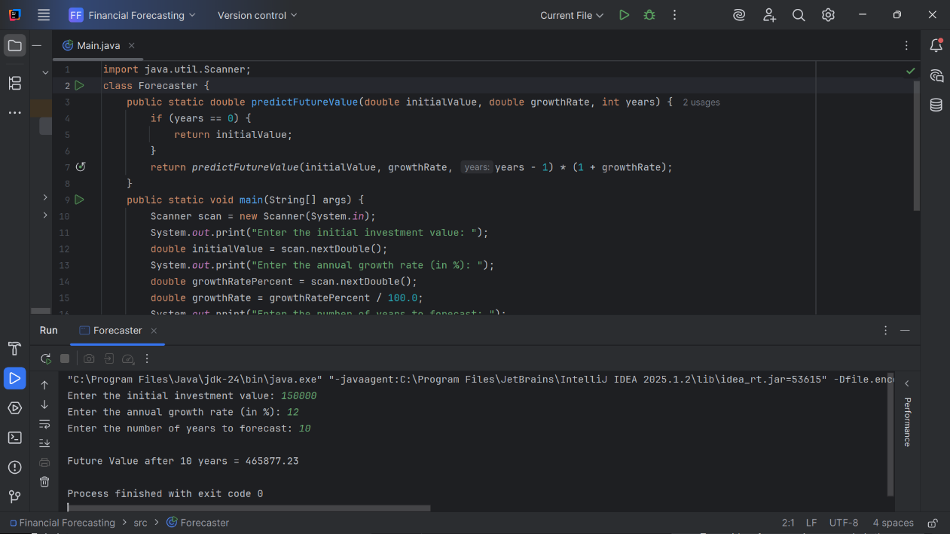**OUTPUT:**